Watershed Work Group
Meeting Minutes
January 10, 2017
Opened: 6:05 pm – Adjourned: 8:00 pm

Attendance
Members: Myrn Stewart, Michael K. Beyer, Larry Boltz, Jeanne Rehwaldt, Tom Bloomfield, Allan Borden, William Short, Fran Janny, Katie Ladner, Erin Ewald, Carmen Echeverria, and Laurie Hagar
Mason Conservation District Staff: John Bolendar, Jennifer Holderman, Barbara Adkins*
Facilitator: John Kliem, Creative Community Solutions, Inc.

Agenda

- Getting to know each other
- Learning about the Voluntary Stewardship Program (VSP) and Q & A
- Selecting a chair, decision model
- Homework assignment, next meeting topic and date

Minutes

Getting To Know Each Other
Facilitator Kliem opened the meeting with Staff introductions and a group activity designed to help members learn more about each other. As part of the getting to know each other exercise, each person was asked to provide two positive behaviors they believe people should bring to the table while working with this group. The following represents the groups’ individual responses:

Listening
Asking questions
Resisting urge to interrupt
Engaging everyone in discussion
Positive outlook
Fun
Positive outlook
Good listening skills
Making a difference
Interest in agriculture
Flexibility
Willingness to work with other’s opinion
Give perspective from experience
Listen to other’s perspective
Open minded, listen
Ability to communicate in group discussion
Long term vision
Be on time
Be respectful
Understand clear goals/objectives for task at hand
Mutual goals
Clear communication
Mindful listening
Follow lead of facilitator

The behaviors listed by the Group will become a model of group behavior for future meetings. Mr. Kliem will make this list available at each meeting as a friendly reminder.

Learning about the Voluntary Stewardship Program (VSP) and Q & A
At the end of the introduction activity, Mr. Kliem gave a PowerPoint presentation with background information on the Voluntary Stewardship Program and its processes. A copy of the PowerPoint was provided to each of the members in notebooks, along with other materials relevant to VSP. Additional materials will be provided as they are requested and as information is distributed to the group at future meetings. After the presentation, there was a period for questions answers. This discussion included:

Are the Tribes interested in participating? Both tribes (Skokomish and Squaxin Island) have been and will continue to be invited to participate; and may attend future meetings. Keeping the Tribes informed as to the Group’s progress will be mandatory, and important for the Plan’s overall success.

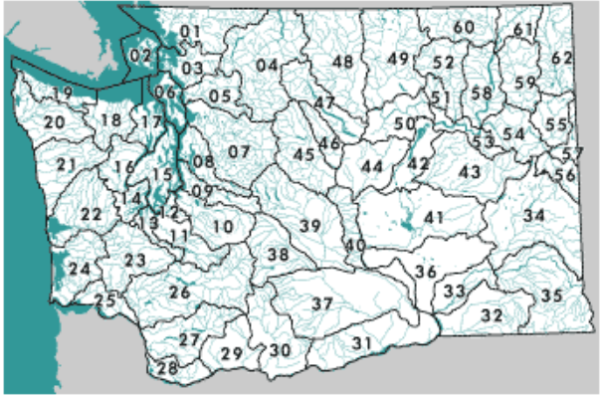
Does the County have a watershed plan? There is not a single watershed plan, as there are several watersheds that cover the County’s total area. In the past, watershed plans for Watershed Resource Inventory Area (WRIA) 14 and 16 have been drafted, ultimately only the WRIA 16 Plan was ever adopted. Five watersheds were included in the County Commissioner’s Resolution to opt in to the VSP process: 14 Kennedy-Goldsborough, 15 Kitsap, 16 Skokomish-Dosewallips, 21 Queets-Quinault, and 22 Lower Chehalis.

The map above is taken from the Washington Department of Ecology’s website and illustrates the location of all five watersheds with respect to Mason County.

Are there maps of the Critical Areas? Information on critical areas, farms, and agriculture land is being compiled in order to provide relevant information for this process. The amount of agricultural land in the Assessor’s open space program, the number and characteristics of farms, and long term agricultural resource lands will be necessary in order to realize how much affected area there is in Mason County. Statistical and illustrative (maps) information will be provided to the Group as it becomes available.

What about Agritourism? Marijuana businesses? Agricultural tourism is based on attracting the public to participate recreationally in agricultural and farming activities and events. It would follow logically that a farm of some sort would be associated with it and therefore already included in the data. As for marijuana, the producers were not specifically targeted to participate. This industry is not typically located in agricultural lands within Mason County, since most of the plants are grown indoors on commercial or industrial zoned property. The topic can be brought back up for discussion at future meetings should the group be interested.

Selecting a Chair, Decision Model
Mr. Kliem asked if anyone in the group was interested in acting as chair. A noticeable lack of raised hands led to holding over the election of a chair until a later meeting. Some group members were not in attendance and may be interested in volunteering or participating in that vote.

Homework Assignment, Next Meeting Topic and Date
Each group member in attendance was given a worksheet to take home and complete. The worksheet has one question: What are the three greatest concerns about the future for agriculture in Mason County? The responses can be emailed back and the results will be provided to the group at the next meeting.

The next meeting will be January 24, 2016 at 6:00 p.m. at the same location: Mason County Public Works, 100 West Public Works Drive in Shelton.

*MCD Staff/VSP Contact:
Barbara Adkins, AICP
Special Programs Manager
Mason Conservation District
(360) 427-9436, Ext 104

A "watershed" is an area draining into a river, lake, or other waterbody. Ecology and other state natural resources agencies have divided the state into 62 "Water Resource Inventory Areas" or "WRIAs" to delineate the state's major watersheds. Washington Department of Ecology. http://www.ecy.wa.gov/water/wria/index.html. January 11, 2017

